**A Project Report on**

**Face Recognition Attendance System**

submitted in partial fulfillment for the award of

**Bachelor of Technology**

in

**Computer Science & Engineering**

by

**K. Haritha (Y20ACS463) D.L. Thirupathi Rao (Y20ACS441)**

**B. Nikitha (Y20ACS413) D. Supriya(Y20ACS443)**



Under the guidance of

**Mrs. M. Karuna**

Department of Computer Science and Engineering

**Bapatla Engineering College**

(Autonomous)

(Affiliated to Acharya Nagarjuna University)

**BAPATLA – 522 102, Andhra Pradesh, INDIA**

**2023-2024**

**Department of**

**Computer Science & Engineering**



**CERTIFICATE**

This is to certify that the project report entitled **Face Recognition Attendance System** that is being submitted by K. Haritha (Y20ACS463), D.L.Thirupathi Rao (Y20ACS441), B. Nikitha (Y20ACS413), D. Supriya(Y20ACS443) in partial fulfillment for the award of the Degree of Bachelor of Technology in Computer Science & Engineering to the Acharya Nagarjuna University is a record of bonafide work carried out by them under our guidance and supervision.

Date:

**Signature of the Guide Signature of the HOD**

**Mrs. M. Karuna Dr. M. Rajesh Babu**

**Asst. Professor Prof. & Head**

**Declaration**

We declare that this project work is composed by ourselves, and that the work contained herein is our own except where explicitly stated otherwise in the text, and that this work has not been submitted for any other degree or professional qualification except as specified.

**K. Haritha (Y20ACS463)**

**D.L. Thirupathi Rao(Y20ACS441)**

**B. Nikitha(Y20ACS413)**

**D. Supriya(Y20ACS443)**

**Acknowledgement**

We sincerely thank the following distinguished personalities who have given their advice and support for successful completion of the work.

We are deeply indebted to our most respected guide **Mrs.M.Karuna**, Asst. Professor, Department of CSE, for her valuable and inspiring guidance, comments, suggestions and encouragement.

We extend our sincere thanks to **Dr.M.Rajesh Babu**, Prof. & Head of the Dept. for extending his cooperation and providing the required resources.

We would like to thank our beloved Principal, **Dr. Nazeer Shaik** for providing the online resources and other facilities to carry out this work.

We would like to express our sincere thanks to the project coordination committee and our project coordinator **Dr. K. Manideep,** Prof., Dept. of CSE for their helpful suggestions throughout the project work and in presenting this document.

We extend our sincere thanks to all other teaching faculty and non-teaching staff of the department, who helped directly or indirectly for their cooperation and encouragement.

**K.Haritha (Y20ACS463)**

**D.L.Thirupathi Rao(Y20ACS441)**

**B.Nikitha(Y20ACS413)**

**D. Supriya(Y20ACS443)**

# Table Of Contents

List Of Figures vii

List Of Tables viii

Abstract ix

1 Introduction 1

1.1 Need for study: 1

1.2 Problem Definition: 2

1.3 Scope of the work: 2

2 Literature Review 4

2.1 Review Of The Project 4

2.2 Limitations of Existing System 5

2.3 Comparision 7

3 System Analysis 7

3.1 Requirements Specification 7

3.1.1 Functional Requirements 8

3.1.2 Non functional requirements 9

3.1.3 User requirements 11

3.1.4 Software Requirements 11

3.1.5 Visual Studio Code 11

3.1.5 Hardware Requirements 12

3.2 UML Diagrams For The Project Work 14

3.2.1 Usecase Diagram 16

3.2.2 Activity Diagram 17

3.2.3 Sequence Diagram 19

3.2.4 Class Diagram 20

4 System Design 22

4.1 Architecture of the Proposed System 22

4.2 Workflow of the proposed system 23

4.3 Modules to be Implemented 24

4.3.1 Face Recognition Module: 24

4.3.2 Dlib Module: 24

4.3.3 Schedule Task Module: 25

4.4 Libraries 25

5 Implementation 28

5.1 Algorithms 28

5.2 Dataset 29

6 Testing 32

6.1 Introduction to testing 32

6.2 Test cases 35

7 Conclusion and Future work 39

7.1 Conclusion 39

7.2 Future Work 40

8 References 41

## List Of Figures

Figure ‎3.2.1 Use CaseDiagram 17

Figure ‎3.2.2 Activity Diagram 19

Figure ‎3.2.3 Sequence Diagram 20

Figure ‎3.2.4 Class Diagram 22

## List Of Tables

Table ‎2.3 Comparison 7

## Abstract

Facial recognition technology is crucial in modern identification systems, providing a rapid and precise method of identifying individuals based on their unique facial features. In today's security-conscious world, this technology plays a vital role, with advanced algorithms like Haar cascade and modules like face recognition and dlib proving superior to traditional methods in challenging conditions such as low light.

Integration of these cutting-edge algorithms in modern facial recognition projects aims to address previous system limitations while improving accuracy and efficiency. High-resolution cameras are pivotal in enabling detailed facial analysis, particularly fortasks like attendance tracking in educational settings, enhancing identification accuracy and streamlining administrative processes.

Facial recognition technology also facilitates proactive communication between educational institutions and parents, with instant notifications of student absences ensuring timely accountability. Monthly progress reports sent directly to parents' mobile devices foster collaboration and contribute to students' academic success, underscoring the technology's significance in enhancing efficiency, accuracy, and meaningful engagement across various domains, including education.Top of Form

## 1 Introduction

### Need for study:

Facial recognition technology is crucial in modern identification systems, providing a rapid and precise method of identifying individuals based on their unique facial features. In today's security-conscious world, this technology plays a vital role, with advanced algorithms like Haar cascade and modules like face recognition and dlib proving superior to traditional methods in challenging conditions such as low light.

Integration of these cutting-edge algorithms in modern facial recognition projects aims to address previous system limitations while improving accuracy and efficiency. High-resolution cameras are pivotal in enabling detailed facial analysis, particularly for tasks like attendance tracking in educational settings, enhancing identification accuracy and streamlining administrative processes.

Facial recognition technology also facilitates proactive communication between educational institutions and parents, with instant notifications of student absences ensuring timely accountability. Monthly progress reports sent directly to parents' mobile devices foster collaboration and contribute to students' academic success, underscoring the technology's significance in enhancing efficiency, accuracy, and meaningful engagement across various domains, including education.

### Problem Definition:

Existing facial recognition systems often struggle with accuracy, particularly in low-light conditions typical of educational environments. Traditional methods like Eigenface and Fisherface lack robustness in such scenarios, highlighting the need for advanced algorithms like Haar cascade and modules like . These algorithms offer consistent and reliable performance, making them superior choices for facial recognition tasks in challenging environments.

There is an urgent need for a comprehensive facial recognition system that integrates LBPH and Haar cascade algorithms to ensure accurate identification under varying lighting conditions. Additionally, incorporating proactive communication features, such as instant notifications for student absences and monthly progress reports to parents, can enhance collaboration between educational institutions and parents, ultimately improving academic outcomes.

### Scope of the work:

The proposed facial recognition system holds significant implications for educational institutions and beyond. By addressing the limitations of existing systems and integrating advanced algorithms like LBPH and Haar cascade, the project aims to enhance the accuracy and reliability of facial recognition, particularly in challenging low-light conditions commonly encountered in educational settings.

Furthermore, the incorporation of proactive communication features, such as instant notifications for student absences and monthly progress reports to parents, fosters greater transparency and accountability between educators and parents. This not only strengthens the collaborative relationship between stakeholders but also contributes to improved student outcomes by promoting parental involvement in their child's education.

Overall, the development and implementation of this comprehensive facial recognition system have the potential to streamline administrative processes, enhance security measures, and facilitate more meaningful engagement within educational environments. Moreover, the technology's scalability opens doors for applications beyond academia, ranging from security and access control to personalized customer experiences in various industries.

## Literature Review

### 2.1 Review Of The Project

In our face detection attendance system, we utilize Haar cascade algorithm and modules like face_recognition and dlib, integrated with Selenium for web automation and scheduled tasks for streamlined operation. This combination ensures accurate detection and efficient attendance tracking, enhancing reliability and usability.

Face recognition attendance systems have gained significant attention due to their potential to automate attendance tracking processes efficiently. Leveraging algorithms such as Haarcascade, face_recognition, and the dlib module, these systems aim to accurately identify individuals based on their facial features. Haarcascade algorithm is commonly used for face detection, while face_recognition and dlib provide robust face recognition capabilities.

Research in this field has focused on improving the accuracy, efficiency, and reliability of face recognition attendance systems. Various studies have explored the integration of deep learning techniques, such as convolutional neural networks (CNNs), for feature extraction and matching, leading to enhanced recognition performance even in challenging conditions.

Applications of face recognition attendance systems span across different sectors, including education, corporate, government, and healthcare. In educational institutions, these systems streamline attendance management, reduce administrative workload, and enhance campus security. Similarly, in corporate settings, they facilitate workforce management, monitor attendance patterns, and ensure compliance with regulations.

Despite their benefits, face recognition attendance systems face challenges related to environmental factors, privacy concerns, algorithmic bias, and ethical considerations. Researchers have addressed these challenges through advancements in algorithm design, data augmentation techniques, and privacy-preserving methods.

Recent trends in face recognition attendance systems include the integration of multimodal biometric techniques, such as fingerprint and iris recognition, for enhanced accuracy and security. Real-world deployments and case studies have demonstrated the practical utility and effectiveness of these systems, driving their adoption across various domains.

In conclusion, face recognition attendance systems represent a promising technology for automating attendance tracking processes. By leveraging algorithms like Haarcascade, face_recognition, and dlib, these systems offer a reliable and efficient solution for managing attendance records in diverse settings. However, addressing challenges related to accuracy, privacy, and ethics remains crucial for ensuring responsible deployment and widespread acceptance of facial recognition technology.

### 2.2 Limitations of Existing System

Existing face recognition attendance systems face several limitations that impede their effectiveness and user satisfaction. One notable drawback is their poor performance in low light conditions. Traditional face recognition algorithms struggle to accurately detect and recognize faces when lighting is inadequate, leading to decreased accuracy and reliability, particularly in indoor environments with insufficient illumination.

Moreover, these systems often suffer from inefficiencies in capturing attendance, especially for large groups of students. The process of capturing facial images, processing them for recognition, and recording attendance data can be slow and cumbersome. This inefficiency can result in delays and frustration among users, particularly in high-traffic areas such as school entrances or corridors.

Additionally, existing systems typically lack built-in features for communicating attendance data to parents or guardians. While they effectively track student attendance within educational institutions, they may not provide mechanisms for automatically notifying parents about their children's attendance status or performance. This limitation can hinder parental engagement and awareness, potentially leading to concerns about student accountability and welfare.

To address these limitations, efforts can be directed towards improving low light performance by developing robust algorithms and incorporating hardware solutions such as infrared or depth sensors. Efficiency enhancements can be achieved through algorithm optimization, parallelization, and hardware acceleration, streamlining the face recognition process and reducing capture times. Furthermore, integrating features for parental communication, such as automatic attendance notifications through email or SMS, can enhance parental engagement and foster transparency in attendance tracking.

By addressing these limitations and continuously innovating in the field of face recognition attendance systems, developers can create more robust, efficient, and user-friendly solutions that meet the needs of educational institutions, organizations, and parents alike.

### 2.3 Comparison

Table 2.3 Comparison

|  |  |  |
| --- | --- | --- |
| **Aspect** | **Existing System** | **Proposed System** |
| Attendance Capture | Captures attendance for individuals sequentially | Captures attendance for entire class simultaneously |
| Monthly Reports | Does not send monthly attendance reports to parents | Sends automated monthly attendance reports to parents |
| Low Light Performance | Performs poorly in low lighting conditions | Enhanced performance in low lighting conditions |
| Time Complexity | Time-consuming due to sequential attendance capture | Reduced time complexity with single-shot attendance capture |
| Parent Notification | Does not notify parents promptly about absences | Sends automated notifications to parents for student absences |

## 3 System Analysis

### 3.1 Requirements Specification

A Software Requirement Specifications (SRS) – a Requirements Specification for a Software System – is a finished depiction of the conduct of a framework to be created. It incorporates a lot of utilization cases that depict every one of the associations the clients will have with the product. Notwithstanding use cases, the SRS additionally contains non-useful necessities. Non-practical necessities are prerequisites which force limitations on the planar usage,(for example, operational efficiency necessities, quality gauges, or structure imperatives).

Business necessities portray in business terms what must be conveyed or achieved to offer some incentive.Product prerequisites portray properties of a framework or item (which could be one of a few different ways to achieve a lot of business necessities.)

Process prerequisites portray exercises performed by the creating association. For example, process necessities could determine explicit approaches that must be pursued, and requirements that the association must comply.

Item and procedure prerequisites are firmly connected. Procedure prerequisites frequently determine the exercises that will be performed to fulfill an item necessity. For instance, a most extreme advancement cost necessity(a procedure prerequisite)might be forced to help accomplish a greatest deals value necessity (an item necessity); a prerequisite that the item be viable(a Product prerequisite) frequently is tended to by forcing necessities to pursue specific improvement styles.

#### 3.1.1 Functional Requirements

Functional requirements for the face recognition attendance system outline the system's interaction with its environment, independent of its implementation.

**Face Detection:** The system must accurately detect human faces within images or video streams captured by the camera. This process involves identifying facial features and localizing faces within the captured frames.

**Face Recognition:** The system should possess the capability to recognize individuals from the detected faces and match them against a database of known individuals. This involves analyzing facial features and patterns to authenticate individuals' identities.

**Attendance Tracking:** It is imperative for the system to record the attendance of recognized individuals in a centralized database. This includes capturing timestamps and identifying individuals present, ensuring accurate attendance records.

**Notification System:** Optionally, the system may include a notification feature to alert administrators or users about attendance-related events, such as late arrivals or absences. Notifications may be sent through various channels like email, SMS, or app notifications.

**User Management:** Administrators should be able to manage users within the system, including adding, editing, or removing individuals from the database. This entails functionalities for user registration, authentication, and access control.

**Reporting:** The system should generate comprehensive attendance reports for specified time periods, individuals, or groups. These reports may include attendance summaries, individual attendance records, and statistical analysis of attendance trends.

#### 3.1.2 Non functional requirements

Non-functional requirements for the face recognition attendance system specify constraints and quality attributes that the system must adhere to, irrespective of its functionality. These requirements focus on aspects such as performance, usability, security, and reliability. Here are some non-functional requirements for the system:

**Performance:** The system should exhibit high performance, with minimal latency in face detection and recognition processes. It should be capable of handling a large number of concurrent users and processing images efficiently, even during peak usage periods.

**Accuracy:** The face recognition algorithm must achieve a high level of accuracy in identifying individuals from facial images. The system should minimize false positives and false negatives to ensure reliable attendance tracking.

**Usability:** The system's user interface should be intuitive and user-friendly, enabling administrators to navigate easily and perform tasks without extensive training. It should provide clear instructions and feedback to users, enhancing usability and adoption.

Security: Ensuring the security and privacy of user data is paramount. The system must implement robust security measures to protect facial images, attendance records, and other sensitive information from unauthorized access, tampering, or theft.

**Reliability:** The system should be reliable and available whenever needed. It should have mechanisms in place to prevent system failures and data loss, with built-in redundancy and failover capabilities to ensure continuous operation.

**Scalability:** The system should be scalable to accommodate future growth and expansion. It should be capable of handling an increasing number of users, facial images, and attendance records without significant degradation in performance or reliability.

**Compatibility:** The system should be compatible with a wide range of devices, operating systems, and web browsers to ensure accessibility and ease of use for users across different platforms.

**Maintainability:** The system should be easy to maintain and update, with well-documented code and modular architecture. It should support seamless upgrades and enhancements without disrupting existing functionalities.

**Regulatory Compliance:** The system must comply with relevant regulations and standards governing data privacy, security, and accessibility, such as GDPR, HIPAA, or ADA. It should adhere to industry best practices and undergo regular audits to ensure compliance.

**Performance Metrics:** The system should have mechanisms in place to monitor and measure its performance, including metrics such as response time, throughput, error rates, and resource utilization. This data can be used to identify bottlenecks, optimize performance, and ensure continuous improvement.

#### 3.1.3 User requirements

Video provides a powerful way to help you prove your point. When you click Online Video, you can paste in the embed code for the video you want to add. You can also type a keyword to search online for the video that best fits your document. To make your document look professionally produced, Word provides header, footer, cover page, and text box designs that complement each other. For example, you can add a matching cover page, header, and sidebar. Click Insert and then choose the elements you want from the different galleries.

Themes and styles also help keep your document coordinated. When you click Design and choose a new Theme, the pictures, charts, and SmartArt graphics change to match your new theme. When you apply styles, your headings change to match the new theme. Save time in Word with new buttons that show up where you need them. To change the way a picture fits in your document, click it and a button for layout options appears next to it. When you work on a table, click where you want to add a row or a column, and then click the plus sign.

#### 3.1.4 Software Requirements

Our face recognition attendance system relies on several essential software components to function effectively:

#### 3.1.5 Visual Studio Code

Our face recognition attendance system is developed within the Visual Studio Code environment. Visual Studio Code is a lightweight yet powerful source code editor known for its intuitive interface and extensive plugin ecosystem. Tailored for Python development on the Windows 10 platform, Visual Studio Code streamlines the coding process with features such as syntax highlighting, code completion, and integrated debugging tools.

Python:

Python serves as the primary coding language for our face recognition attendance system. Renowned for its simplicity and versatility, Python offers extensive libraries and frameworks for image processing, machine learning, and database management. With its intuitive syntax and comprehensive documentation, Python facilitates efficient development and deployment of robust algorithms for facial recognition tasks.

**Windows 10 Compatibility:**

The system is designed to run seamlessly on the Windows 10 operating system, leveraging its compatibility with Visual Studio Code and Python. Windows 10 provides a stable and user-friendly environment for software development, ensuring optimal performance and reliability for the face recognition attendance system. Additionally, Windows 10 offers robust security features and regular updates, enhancing the overall stability and security of the system.

#### 3.1.5 Hardware Requirements

To support the functionality of our face recognition attendance system, the following hardware components are necessary:

**Computer:** A computer system with sufficient processing power and memory is essential for running the system smoothly. We recommend a computer with at least an Intel Core i5 processor and 8GB of RAM to handle the computational demands of image processing and machine learning tasks efficiently.

**Camera:** A high-resolution camera capable of capturing clear images is required for face detection and recognition. We suggest using a camera with a resolution of at least 1080p for optimal results.

**Operating System:** The system is compatible with Windows 10, which provides a stable and user-friendly environment for software development and execution. Additionally, Linux-based operating systems may also be suitable, depending on the user's preferences and requirements.

**Storage:** Sufficient storage capacity is necessary to store image datasets, system files, and database records. We recommend a hard disk with a minimum capacity of 1TB to accommodate the storage needs of the system.

By ensuring the availability of these hardware components, our face recognition attendance system can be effectively deployed and utilized for attendance tracking purposes in various settings.

### 3.2 UML Diagrams For The Project Work

UML is an acronym that stands for Unified Modelling Language. Simply put, UML is a modern approach to modelling and documenting software. In fact, it’s one of the most popular business process modelling techniques.

It is based on diagrammatic representations of software components. As the old proverb says: “a picture is worth a thousand words”. By using visual representations, able to better understand possible flaws or errors in software or business processes.

The elements are like components which can be associated in different ways to make a complete UML picture, which is known as diagram. Thus, it is very important to understand the different diagrams to implement the knowledge in real-life systems.

Any complex system is best understood by making some kind of diagrams or pictures. These diagrams have a better impact on understanding. Look around and realize that the diagrams are not a new concept but it is used widely in different forms in different industries.

Prepare UML diagrams to understand the system in a better and simple way. A single diagram is not enough to cover all the aspects of the system. UML defines various kinds of diagrams to cover most of the aspects of a system. UML was created as a result of the chaos revolving around software development and documentation. In the 1990s, there were several different ways to represent and document software systems. The need arose for a more unified way to visually represent those systems and as a result, in 1994 to1996, the UML was developed by three software engineers working at Rational Software.

Mainly, UML has been used as a general-purpose modelling language in the field of software engineering. However, it has now found its way into the documentation of several business processes or workflows. For example, activity diagrams, a type of UML diagram, can be used as a replacement for flowcharts. They provide both a more standardized way of modelling workflows as well as a wider range of features to improve readability and efficiency. Use cases are best discovered by examining the actors and defining what the actor will be able to do with the system. Since all the needs of a system typically cannot be covered in one use case, it is usual to have a collection of use cases. Together this use case collection specifies all the ways the system. An association provides a pathway for communication. The communication can be between use cases, actors, classes or interfaces. Associations are the most general of all relationships and consequentially the most semantically weak. If two objects are usually considered independently, the relationship is an association. They provide both a more standardized way of modelling workflows as well as a wider range of features to improve readability and efficiency. Use cases are best discovered by examining the actors and defining what the actor will be able to do with the system. Since all the needs of a system typically cannot be covered in one use case, it is usual to have a collection of use cases.

By default, the association tool on the toolbox is unidirectional and drawn on a diagram with a single arrow at one end of the association. The end with the arrow indicates who or what is receiving the communication. A dependency is a relationship between two model elements in which a change to one model element will affect the other model element. Typically, on class diagrams, a dependency relationship indicates that the operations of the client invoke operations of the supplier. The workflow in this case begins from importing the dataset by the developer and then replacing missing values with mean value of corresponding column, model building, validating that model by generating a confusion matrix and finally predicting the test sample class label. Transitions are used to show the passing of the flow of control from activity.

The various UML diagrams are

1. Use case diagram
2. Activity diagram
3. Sequence diagram
4. Class diagram

#### 3.2.1 Use case Diagram

The use case diagram for the face recognition attendance system delineates the essential interactions between users and the system, providing a clear depiction of its functionalities. Administrators wield significant authority within this framework, employing actions like registering new employees and generating attendance reports. Through the "Register Employee" use case, administrators can seamlessly integrate new personnel into the system, ensuring a smooth transition into the attendance tracking process. Moreover, the "Generate Attendance Report" feature empowers administrators to extract actionable insights from attendance data, facilitating informed decision-making and resource optimization across the organization.

Employees, meanwhile, engage with the system predominantly through the "Check In/Out" use case, leveraging facial recognition technology for swift and accurate attendance management. This central use case epitomizes the system's core functionality, enabling employees to record their presence effortlessly while ensuring maximum precision. Together, these use cases encapsulate the face recognition attendance system's fundamental operations, streamlining administrative workflows, boosting organizational efficiency, and fostering a secure and transparent work environment.

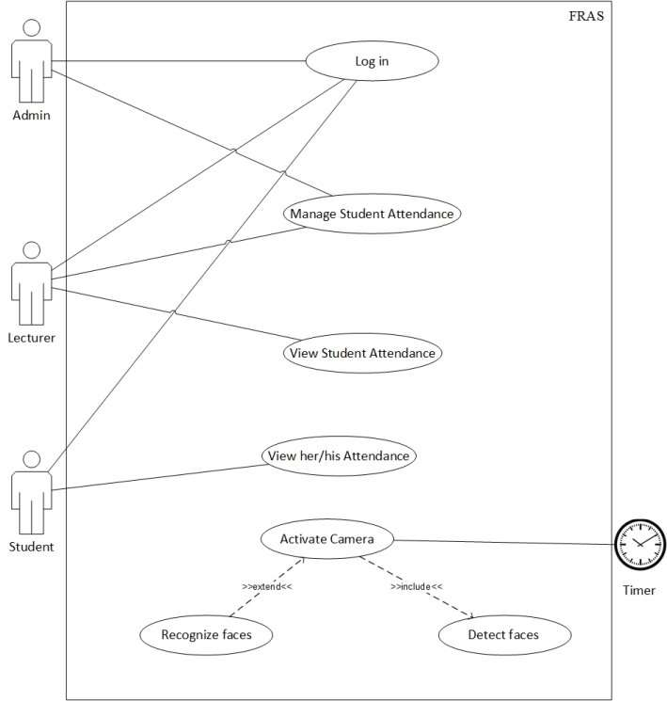

Figure 3.2.1 Use Case Diagram

#### 3.2.2 Activity Diagram

The activity diagram for the face recognition attendance system offers a visual representation of the sequential steps involved in its operation, elucidating the flow of activities from initiation to completion. At the system's core lies the activity of "Recognition Process," where the facial recognition algorithm analyzes captured images to identify registered employees. This process entails sub-activities such as face detection, feature extraction, and matching against stored templates. Upon successful recognition, the system proceeds to log the employee's attendance, marking the beginning or end of the work session. Conversely, if recognition fails, the system initiates an error handling routine, prompting the user for reauthentication or notifying the administrator for further assistance.

Parallel to the recognition process, administrative activities unfold, encapsulated within the "Administration Tasks" activity. Here, administrators engage in tasks such as employee registration and attendance management. The sub-activities include "Register Employee," where administrators input new employee data into the system, and "Generate Attendance Report," enabling them to extract comprehensive reports for analysis. These administrative tasks run independently of the recognition process, highlighting the system's multitasking capabilities. Through this activity diagram, the intricate choreography of interactions between users and the system is delineated, underscoring its efficiency in attendance tracking and management.

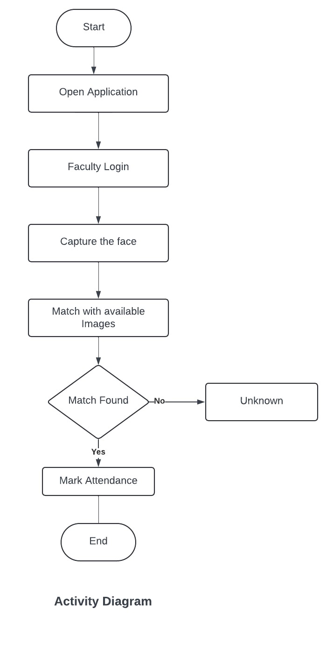

Figure 3.2.2 Activity Diagram

#### 3.2.3 Sequence Diagram

In the sequence diagram for the face recognition attendance system, the interactions between actors (users) and the system are depicted in a chronological sequence, illustrating the exchange of messages and the flow of control. At the outset, the sequence commences with the "Employee Recognition" message, indicating the initiation of the face recognition process triggered by an employee's presence in front of the system. This message prompts the system to commence the facial recognition algorithm, encompassing steps such as image capture, facial feature extraction, and template matching against registered profiles.

Upon successful recognition, the system sends a "Attendance Logged" message to confirm the employee's presence, updating the attendance records accordingly. Concurrently, administrative tasks unfold in parallel, symbolized by messages such as "Register Employee" and "Generate Attendance Report." These interactions exemplify the system's capability to handle simultaneous operations, with administrators executing tasks like employee registration and attendance report generation autonomously. Conversely, in cases of recognition failure, an "Error Handling" message is dispatched, initiating corrective measures such as user notification or administrator intervention. Through this sequence diagram, the orchestration of events within the face recognition attendance system is elucidated, showcasing its seamless operation and robust functionality in tracking and managing attendance.

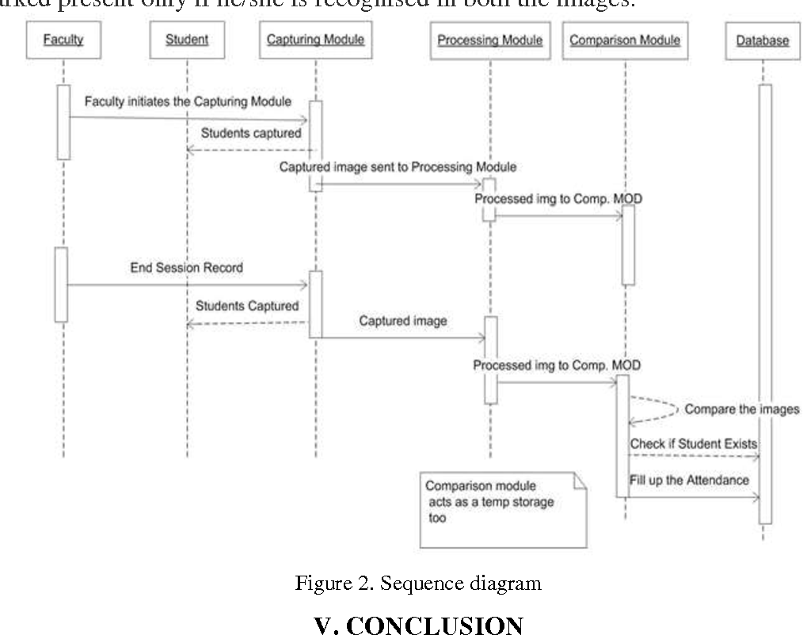

Figure 3.2.3 Sequence Diagram

#### 3.2.4 Class Diagram

In the class diagram for the face recognition attendance system, the various classes and their relationships within the system are illustrated, providing a blueprint for its structure and functionality. At the core of the system lies the "Employee" class, representing individual employees registered within the system. This class encapsulates attributes such as employee ID, name, and facial template, facilitating the storage and retrieval of employee information for recognition purposes.

Adjacent to the "Employee" class is the "AttendanceRecord" class, responsible for logging attendance data for each employee. This class contains attributes such as timestamp, employee ID, and attendance status, enabling the system to maintain a comprehensive record of employee attendance over time. Additionally, the "Administrator" class governs administrative functionalities within the system, encompassing actions like employee registration and attendance report generation. Administrators possess attributes such as username and password for secure access to administrative features.

Furthermore, the "RecognitionSystem" class serves as the central component responsible for executing the facial recognition algorithm and managing recognition processes. It interacts with the "Employee" class to retrieve employee data for recognition and updates the "AttendanceRecord" class upon successful recognition. Moreover, auxiliary classes such as "ErrorHandling" and "ReportGeneration" handle error handling routines and report generation functionalities, respectively, enhancing the system's robustness and versatility. Through this class diagram, the structural hierarchy and interconnections of classes within the face recognition attendance system are delineated, providing a comprehensive overview of its architecture and capabilities.

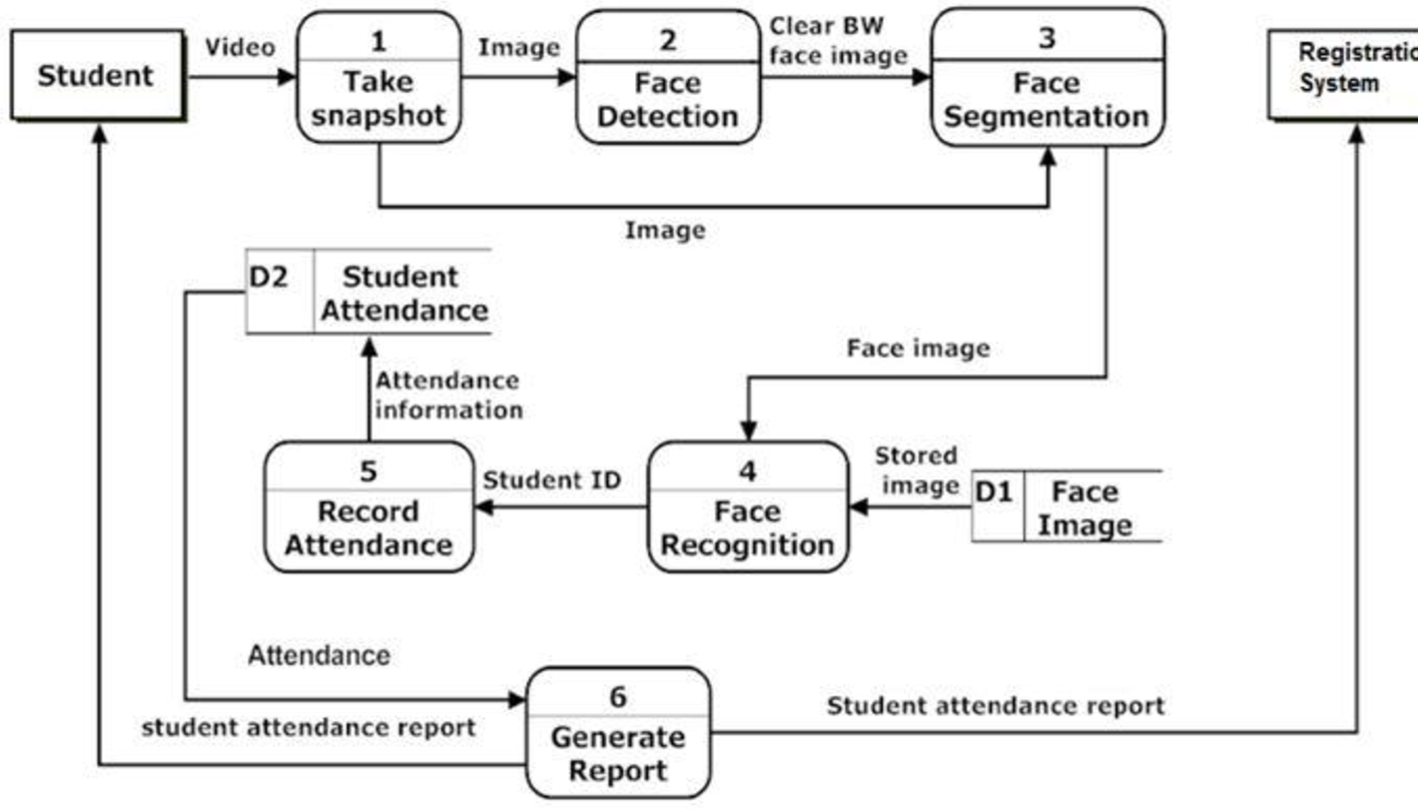

Figure 3.2.4 Class Diagram

## 4 System Design

### 4.1 Architecture of the Proposed System

The proposed architecture for a face recognition attendance system entails a layered structure that encompasses various components, each serving distinct roles in the system's operation. At the core of the architecture lies the facial recognition engine, responsible for processing captured images and identifying individuals based on facial features. This engine utilizes advanced algorithms for tasks such as face detection, feature extraction, and template matching, ensuring accurate and reliable recognition.

Surrounding the facial recognition engine are peripheral components such as cameras and sensors, which capture images of individuals for recognition purposes. These devices interface with the recognition engine, providing input data and facilitating the recognition process. Additionally, data storage and management modules are integrated into the architecture to store employee information, facial templates, and attendance records securely. This includes databases or cloud storage solutions capable of handling large volumes of data while ensuring data integrity and accessibility.

Furthermore, the architecture incorporates a user interface layer, comprising interfaces tailored for different user roles such as administrators and employees. Administrators access administrative functionalities such as employee registration and attendance report generation through a web-based or desktop application interface. Employees, on the other hand, interact with the system primarily through dedicated terminals equipped with facial recognition capabilities, enabling them to check in and out seamlessly.

Moreover, the architecture encompasses security measures to safeguard sensitive data and prevent unauthorized access or tampering. This includes encryption mechanisms for data transmission, authentication protocols to verify user identities, and access control mechanisms to regulate user permissions. Additionally, the architecture may incorporate redundancy and fault tolerance mechanisms to ensure system reliability and continuity of service.

Overall, the proposed architecture for the face recognition attendance system is designed to be scalable, modular, and robust, capable of meeting the evolving needs of organizations across various industries while providing efficient and secure attendance tracking solutions.

### 4.2 Workflow of the proposed system

The workflow of the proposed face recognition attendance system begins with employee registration by administrators, who input employee details and capture facial templates. Employees check in by presenting themselves to the designated terminal, where their facial features are captured and compared with stored templates for identification. Successful recognition results in the logging of check-in time, while recognition failure prompts error handling procedures. At the end of the workday, employees repeat the process for check-out, with successful recognition leading to the logging of check-out time. Administrators can access the system for tasks such as generating attendance reports and managing employee records, ensuring efficient administration. Throughout the workflow, security measures are enforced to protect sensitive data and prevent unauthorized access.

### 4.3 Modules to be Implemented

#### 4.3.1 Face Recognition Module:

The Face Recognition Module incorporates the powerful face recognition library, enabling accurate detection and recognition of faces from images or video streams. Leveraging advanced algorithms, it facilitates facial feature extraction, template generation, and face matching for reliable identification. Additionally, the module includes functionalities for training the recognition model on a dataset of known faces, allowing for customization and optimization to suit specific organizational needs. Furthermore, it provides utilities for handling face embeddings, encoding facial features into numerical vectors for efficient comparison, thus enhancing the system's capability to handle diverse facial characteristics and variations.

#### 4.3.2 Dlib Module:

The Dlib Module integrates the versatile Dlib library, offering functionalities for face detection, facial landmark detection, and pose estimation. This enhances the system's accuracy and precision, utilizing pre-trained models and utilities for comprehensive analysis and debugging. Moreover, the module includes features such as object detection and shape prediction, extending its utility beyond facial recognition to various computer vision tasks. Additionally, it provides tools for image manipulation and feature extraction, enabling advanced image processing techniques to enhance facial recognition performance further.

#### 4.3.3 Schedule Task Module:

The Schedule Task Module automates recurring tasks within the attendance system, scheduling tasks such as data backups or report generation. It offers flexibility in task scheduling, error handling mechanisms, and logging functionalities, enhancing system efficiency and reliability while streamlining administrative operations. Furthermore, the module includes features for task prioritization and resource allocation, ensuring optimal utilization of system resources and timely execution of critical tasks. Additionally, it provides support for task dependencies and conditional scheduling, enabling complex task workflows and automation scenarios to be implemented effectively.

### 4.4 Libraries

**pickle:** The pickle module is used for serializing and deserializing Python objects. In this context, it may be used for saving and loading trained machine learning models or other data structures to/from disk.

**cv2 (OpenCV):**The cv2 module is an OpenCV library, which is a popular computer vision library in Python. It provides various functionalities for image and video processing, including reading and writing images, video capture, image manipulation, and object detection.

**Os:** The os module provides functions for interacting with the operating system, such as working with files and directories. It may be used in the script for tasks such as file path manipulation and directory operations.

**winsound:** The winsound module provides access to sound-playing functionality on Windows platforms. It may be used for playing sound notifications or alerts in the script.

**face_recognition:** The face_recognition module is a popular library for face detection and recognition tasks. It provides high-level functions for facial recognition, including face detection, facial landmark detection, and face encoding.

**Flask**: The Flask module is a web framework for building web applications in Python. It provides functionalities for routing HTTP requests, rendering templates, managing sessions, and more. In this script, Flask is used for creating a web-based interface for the face recognition attendance system.

**datetime:** The datetime module provides classes for manipulating dates and times in Python. It is used in the script for working with timestamps and date-related operations.

**numpy:** The numpy module is a fundamental package for scientific computing with Python. It provides support for multi-dimensional arrays and matrices, along with mathematical functions to operate on these arrays efficiently.

**scikit-learn (sklearn):** The scikit-learn module is a machine learning library for Python. In this script, specifically, the KNeighborsClassifier class from scikit-learn is used for implementing the k-nearest neighbors classification algorithm.

**pandas:** The pandas module is a powerful data manipulation and analysis library in Python. It provides data structures and functions for working with structured data, such as data frames, which are used for data preprocessing and analysis.

**joblib:** The joblib module is used for efficiently saving and loading Python objects, especially large NumPy arrays. It is often used in conjunction with scikit-learn for saving trained machine learning models to disk.

**time:** The time module provides functions for working with time-related tasks in Python. It may be used for tasks such as measuring code execution time, adding delays, or working with timestamps.

## 5 Implementation

### 5.1 Algorithms

The word [**Algorithm**](https://www.geeksforgeeks.org/fundamentals-of-algorithms/)means “a process or set of rules to be followed in calculations or other problem-solving operations”. Therefore, Algorithm refers to a set of rules/instructions that step-by-step define how a work is to be executed upon in order to get the expected results.

It can be understood by taking an example of cooking a new recipe. To cook a new recipe, one reads the instructions and steps and execute them one by one, in the given sequence. The result thus obtained is the new dish cooked perfectly. Similarly, algorithms help to do a task in programming to get the expected output. The Algorithm designed are language-independent, i.e. they are just plain instructions that can be implemented in any language, and yet the output will be the same, as expected.

The Haar cascade algorithm, developed by Viola and Jones, revolutionized object detection in images. It operates by first creating an integral image representation of the input image, enabling rapid computation of pixel sums within rectangular regions. Haar-like features, simple rectangular patterns describing object characteristics, are then selected based on their discriminatory power between object and background regions. Adaboost training is applied to select the most discriminative features and train a classifier, organizing it into a cascade of stages for efficient rejection of non-object regions.

During detection, the cascade classifier is applied using a sliding window approach across multiple scales and positions in the image. Positive classifier responses at various scales and positions indicate potential object detections. The algorithm localizes detected objects based on these responses, with additional post-processing steps refining localization and eliminating false positives. With its efficient scanning of images and accurate object identification, the Haar cascade algorithm finds wide application in tasks like face detection and recognition in photographs and video streams.

### 5.2 Dataset

For the face recognition attendance system, a dynamic dataset acquisition process is essential to ensure accurate and robust model training. The system should be designed to dynamically capture multiple photos of each student, typically around 10 photos, to enhance the diversity and representation of facial images for each individual. Here's a detailed overview of the dataset acquisition process:

**Dynamic Photo Capture:** The system dynamically captures facial images of students using the camera module. When a student initiates the registration or enrollment process, the system prompts them to stand in front of the camera, ensuring proper lighting and positioning for optimal image quality.

**Multiple Photo Shots:** During the registration process, the system takes multiple photos of the student's face from different angles and expressions. This ensures that the dataset includes diverse facial images, capturing variations in facial features, poses, and lighting conditions.

**Variability in Poses and Expressions:** To enhance the robustness of the face recognition model, the system encourages students to pose naturally and express different facial expressions during photo capture. This variability helps the model generalize better to unseen faces and adapt to variations in real-world scenarios.

**Real-time Feedback:** The system provides real-time feedback to students during the photo capture process, guiding them to adjust their poses or expressions for optimal image quality. This interactive feedback loop ensures that the captured dataset is of high quality and representative of real-world scenarios.

**Quality Assurance:** After capturing each photo, the system performs quality assurance checks to ensure that the images meet predefined criteria for clarity, focus, and alignment. Images that do not meet the quality standards are discarded, and additional photos are captured if necessary.

**Dataset Annotation:** Once the photos are captured, the system annotates each image with metadata, including the student's identity and any relevant contextual information. This metadata is used during the model training process to associate each facial image with the corresponding student.

**Model Training:** The annotated dataset, consisting of multiple photos for each student, is used to train the face recognition model. The model learns to extract meaningful features from the facial images and differentiate between different individuals based on their unique characteristics.

**Iterative Training Process:** The model training process may be iterative, with periodic updates and refinements based on feedback from system administrators or users. Additional photos may be captured and added to the dataset over time to further improve the model's accuracy and performance.

## 6 Testing

### 6.1 Introduction to testing

Testing is a fault detection technique that tries to create failure and erroneous states in a planned way. This allows the developer to detect failures in the system before it is released to the customer.

Note that this definition of testing implies that a successful test is test that identifies faults. So use this definition throughout the definition phase. Another often used definition of testing is that it demonstrates that faults are not present. Testing can be done in two ways: 1. Top-down approach 2. Bottom-up approach

1. Top-down approach:

This type of testing starts from upper-level modules. Since the detailed activities usually performed in the lower-level routines are not provided stubs are written.

2. Bottom-up Approach:

Testing can be performed starting from smallest and lowest level modules and proceeding one at a time. For each module in bottom up testing a short program executes the module and provides the needed data so that the module is asked to perform the way it will when embed within the larger system. In this project, bottom-up approach is used where the lower-level modules are tested first and the next ones having much data in them. Testing Methodologies, The following are the Testing Methodologies:

1. Unit Testing.

2. Integration Testing.

3. User Acceptance Testing.

4. Output Testing.

**Unit Testing**

Unit testing focuses verification effort on the smallest unit of Software design that is the module. Unit testing exercises specific paths in a modules control structure to ensure complete coverage and maximum error detection. This test focuses on each module individually, ensuring that it functions properly as a unit. Hence, the naming is 30 Unit Testing. During this testing, each module is tested individually and the module interfaces are verified for the consistency with design specification. All-important processing path are tested for the expected results. All error handling paths are also tested.

**Integration Testing**

Integration testing addresses the issues associated with the dual problems of verification and program construction. After the software has been integrated a set of high order tests are conducted. The main objective in this testing process is to take unit tested modules and builds a program structure that has been dictated by design.

The following are the types of Integration Testing:

**1.Top-Down Integration**

This method is an incremental approach to the construction of program structure. Modules are integrated by moving downward through the control hierarchy, beginning with the main program module. The module subordinates to the main program module are incorporated into the structure in either a depth first or breadth first manner. In this method, the software is tested from main module and individual stubs are replaced when the test proceeds downwards.

**2.Bottom-up Integration**

This method begins the construction and testing with the modules at the lowest level in the program structure. Since the modules are integrated from the bottom up, processing required for modules subordinate to a given level is always available and the need for stubs is eliminated. The bottom-up integration strategy may be implemented with the following steps:

1. The low-level modules are combined into clusters into clusters that perform a specific Software sub-function.
2. A driver (i.e.) the control program for testing is written to coordinate test case input and output.
3. The cluster is tested, and drivers are removed and clusters are combined moving upward in the program structure. The bottom-up approaches test each module individually and then each module is module is integrated with a main module and tested for functionality.

**3.User Acceptance Testing**

User Acceptance of a system is the key factor for the success of any system. The system under consideration is tested for user acceptance by constantly keeping in touch with the prospective system users at the time of developing and making changes wherever required. The system developed provides a friendly user interface that can easily be understood even by a person who is new to the system.

**4.Output Testing**

After performing the validation testing, the next step is output testing of the proposed system, since no system could be useful if it does not produce the required output in the specified format. Asking the users about the format required by them tests the outputs generated or displayed by the system under consideration. Hence the output format is considered in 2 ways one is on screen and another in printed format.

### 6.2 Test cases

Test cases for a face recognition attendance system cover various scenarios to validate its functionality, accuracy, and reliability. Here are some possible test cases:

**Registration and Enrollment:**

Verify that new students can register and enroll in the system.

Test the capturing of facial images during registration.

Ensure that student data is accurately stored in the database.

**Face Detection:**

Test the system's ability to detect faces in different lighting conditions.

Verify face detection accuracy for varying facial expressions and poses.

Ensure that the system can detect faces with different skin tones and features.

**Face Recognition:**

Test the accuracy of face recognition for enrolled students.

Verify that the system correctly identifies enrolled students during attendance recording.

Test face recognition performance with a large number of enrolled students.

**Attendance Recording:**

Verify that attendance is accurately recorded based on recognized faces.

Test attendance recording for multiple students simultaneously.

Ensure that attendance records are correctly timestamped and stored in the database.

**Error Handling:**

Test error handling for scenarios such as unrecognized faces or system failures.

Verify that appropriate error messages are displayed to users.

Test system recovery mechanisms after errors occur.

**Performance Testing:**

Evaluate the system's performance under normal and peak loads.

Test response time for face detection, recognition, and attendance recording.

Measure system scalability by simulating concurrent user interactions.

**Usability Testing:**

Evaluate the user interface for clarity, intuitiveness, and ease of navigation.

Test user interactions for tasks such as registration, attendance recording, and data retrieval.

Gather feedback from users to identify usability issues and areas for improvement.

**Security Testing:**

Test system security measures such as user authentication and data encryption.

Verify protection against unauthorized access, data breaches, or spoofing attacks.

Evaluate the system's resilience to common security threats and vulnerabilities.

**Robustness Testing:**

Test the system's performance under different environmental conditions.

Verify face recognition accuracy in various lighting conditions, angles, and distances.

Evaluate robustness to occlusions such as glasses, hats, or facial hair.

**Integration Testing:**

Test the integration of face recognition with other system components such as attendance management and reporting.

Verify data consistency and accuracy across integrated modules.

Ensure seamless communication and data exchange between system components.

**Compatibility Testing:**

Test the system's compatibility with different hardware devices such as cameras and computers.

Verify compatibility with various operating systems and web browsers.

Test interoperability with other software systems or databases used in the organization.

## 7 Conclusion and Future work

### 7.1 Conclusion

In summary, the implementation of a face recognition attendance system represents a significant leap forward in modern attendance tracking methodologies. By harnessing the power of advanced facial recognition algorithms and machine learning techniques, this system offers unparalleled accuracy and efficiency in recording attendance. With its automated processes and swift face detection capabilities, the system streamlines the attendance recording process, saving valuable time for both students and educators.

Moreover, the integration of security features ensures the safeguarding of sensitive attendance data, providing peace of mind for educational institutions and organizations. Through user-friendly interfaces and seamless integration with existing workflows, the system enhances the overall user experience, making attendance management more intuitive and accessible. Additionally, the system's ability to analyze attendance data offers valuable insights into attendance patterns, enabling administrators to make informed decisions and implement effective attendance management strategies.

Overall, the face recognition attendance system represents a transformative solution for attendance tracking, offering a blend of accuracy, efficiency, and security. By embracing innovative technologies, educational institutions and organizations can revolutionize their attendance management processes, paving the way for improved operational efficiency and enhanced student engagement.

### 7.2 Future Work

Real-time Monitoring and Notifications: Implementing real-time monitoring capabilities would allow administrators to track attendance dynamically and receive instant notifications for irregularities or absences. This proactive approach could help address attendance issues promptly and ensure timely intervention when needed.

**Mobile Application Development:** Developing a dedicated mobile application for the attendance system would offer greater flexibility and accessibility for users. Students could conveniently check in for classes using their smartphones, while educators and administrators could manage attendance on the go, enhancing overall usability and convenience.

**Integration of Biometric Authentication:** Expanding the system's capabilities to include biometric authentication methods beyond facial recognition, such as fingerprint or iris scanning, could offer additional layers of security and accuracy. This would provide users with multiple options for verifying their identity, catering to diverse preferences and scenarios.

**User Feedback and Continuous Improvement:** Incorporating mechanisms for gathering user feedback and implementing continuous improvement processes will be essential for the long-term success of the attendance system. Regularly soliciting input from stakeholders and iterating on system features based on their insights will ensure that the system remains relevant, efficient, and user-friendly over time.

## 8 References

[1] Ramyashree, P. S. Venugopala, "Proposal for Enhancing Face Detection in Group Photos", Applied and Theoretical Computing and Communication Technology (iCATccT) 2018 4th International Conference on, pp. 113-118, 2018.

[2] J. Yan, X. Zhang, Z. Lei, and S. Z. Li, “Face detection by structural models,” Image and Vision Computing, vol. 32, no. 10, pp. 790–799, 2014.

[3] Jurgen Schmidhuber, "Deep learning in neural networks: An overview", Neural Networks, vol. 61, pp. 85-117, 2015.

[4] G. Hu, Y. Yang, D. Yi, J. Kittler, W. J. Christmas, S. Z. Li, T. M. Hospedales, "When face recognition meets with deep learning: an evaluation of convolutional neural networks for face recognition", CoRR abs/1504.02351, 2015.

A. P. Engelbrecht, “Computational Intelligence: An Introduction,” Wiley & Son Ltd, 2007.

[6] Yann Le Cun, Yoshua Bengio, Geoffrey Hinton, "Deep learning", Nature, vol. 521, no. 7553, pp. 436-444, 2015.

[7] Y Sun, X Wang, X. Tang, "Deep learning face representation from predicting 10000 classes[C]", Proceedings of IEEE Conference on Computer Vision and Pattern Recognition, pp. 1891-1898, 2014.

[8] M Y Liu, S X Li, S G Shan et al., "Deeply learning feformable facial action parts model for dynamic expression analysis[M]" in Computer Vision-ACCV 2014, Springer International Publishing, pp. 143-157, 2014.